

DBMS(LAB MANUAL)

Lab Manual

[Fall 2019]

NABEEL AHMED

ID 13839

FACULTY : DR,NOMAN ISLAM

**LIST OF EXPERIMENTS**

|  |  |  |  |
| --- | --- | --- | --- |
| **S. No** | **Date** | **Experiment** |  |
| **1** | _/__/__ | To study and explore basic DDL commands in SQL: create, alter, drop |  |
| **2** | __/__/__ | To study and explore basic SQL commands: select, insert, delete, update |  |
| **3** | __/__/__ | To study and explore select command in SQL |  |
| **4** | __/__/__ | To study and implement advanced SQL commands: having and group by |  |
| **5** | __/__/__ | To study and implement sub-queries, various types of joins in SQL |  |
| **6** | __/__/__ | To study and implement data control language |  |
| **7** | __/__/__ | To study and implement triggers in SQL |  |
| **8** | __/__/__ | To study and implement Java Database Connectivity (JDBC) |  |
| **9** | __/__/__ | To study, understand and implement NoSQL databases using MongoDB |  |
| **10** | __/__/__ | To study and implement connectivity with MongoDB using Java |  |

**Lab 1: To study and implement basic DDL commands in SQL: create, alter, drop**

Structured Query Language) is a domain-specific language used in programming and designed for managing data held in a relational database management system (RDBMS). In this lab, we will study basic data definition language of SQL.

**Lab Tasks:**

1. Login to the SQL server with the default user id and password
2. Create a database called School using the CREATE DATABASE command
3. Now create a table Student with fields sid (int), name (varchar), age(int), gender(varchar), address(varchar); set sid as the primary key
4. Alter the table Student to change the data datatype of gender to bit
5. Add the constraint to name to be not null
6. Add the constraint address to be unique
7. Add the constraint age to be always greater than or equal to 18
8. Create a table Semester with sid (int) and sdate(date). Set sid to be primary key and make sure it is auto incremented
9. Alter the table Student to add one more field semester with foreign key constraint
10. Drop all the tables
11. Drop the database

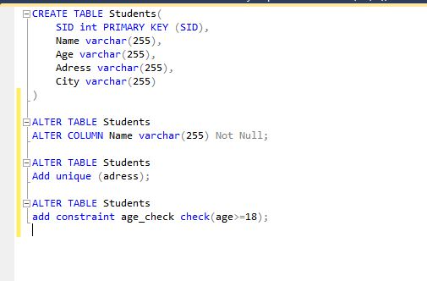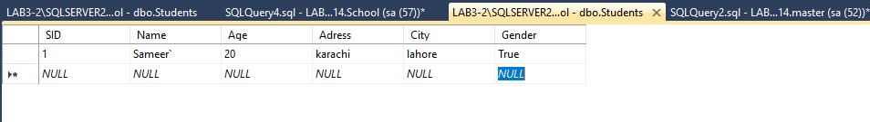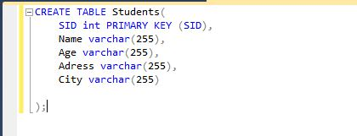

**Lab 2: To study and implement basic SQL commands: select, insert, delete, update**

In this lab, we will study basic DML commands used in SQL.

**Lab Tasks:**

1. Assuming you have the tables created in previous lab, insert five rows in the Student table

|  |  |  |  |  |
| --- | --- | --- | --- | --- |
| **Id** | **Name** | **Age** | **Gender** | **Address** |
| 1 | Ali | 19 | True | Gulberg |
| 2 | Zoya | 18 | False | Nazimabad |
| 3 | Rashid | 21 | True | Quaid-e-bad |
| 4 | Ahmed | 19 | True | Liaquat Abad |
| 5 | Naima | 20 | False | Lahore |

1. Try to insert the following new record. Do you face any issue?

|  |  |  |  |  |
| --- | --- | --- | --- | --- |
| 6 | Asghar | 20 | True | Lahore |

1. Try to insert the following record. Do you face any issue?

|  |  |  |  |  |
| --- | --- | --- | --- | --- |
| 7 | Aleem | 17 | True | Lahore |

1. Now, select all the students from the Student
2. Select all the female students from the Student
3. Select all the distinct age from Student table
4. Update the address of Zoya to Hostel
5. Find all students whose age is greater than 20
6. Count all the students less than 20 years
7. Find all students whose name starts with ‘A’
8. Select all the students order by age
9. Delete the students who age is less than 19
10. Alter the table Student to add a new field: Status of type varchar
11. Set the status of all the students to active

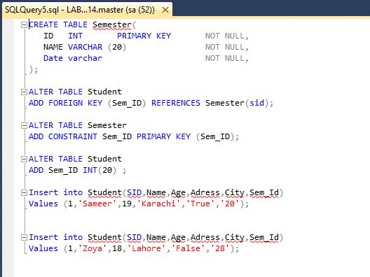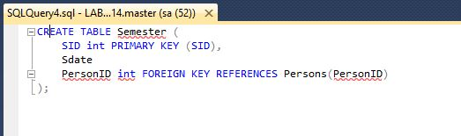

**Lab 3: To study and explore select command in SQL**

In this lab, we will explore the select SQL command in detail. We will see how we can use select command to see different columns in output, how can we apply aggregate functions etc.

**Lab Tasks:**

Consider the tables created in previous labs, now perform the following tasks:

1. Select the names of all the students.
2. Find the average age of the students.
3. Provide the average age an alias of ‘avg_age’.
4. Count the number of records in students table. Provide it a suitable alias.
5. Alter the student table to add a fee column of data type int.
6. Find the total sum of fee.
7. Find the maximum age of students.
8. Find all the details of student whose age is maximum.
9. Find the names of student capitalized.
10. Alter the student table to add a cgpa column of appropriate data type.
11. Select all the records of students. The CGPA should be rounded to two decimal places.
12. List all the details of students sorted by name and age in ascending order.
13. Search the students whose name ends with ‘d’.
14. Find all students whose age lies between 20 and 25.
15. Find the name of student whose lives in Liaquat-e-bad.

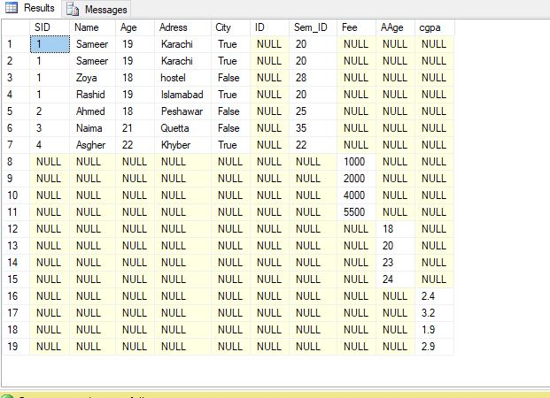

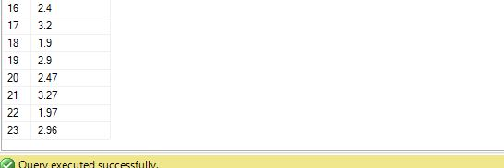

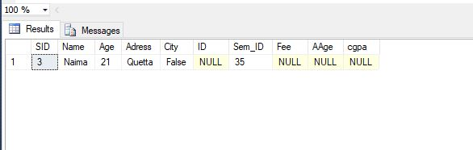

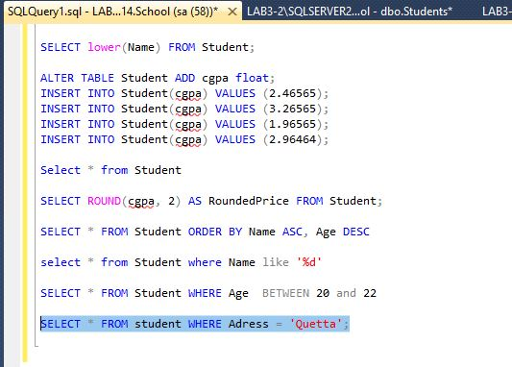

**Lab 4: To study and implement advanced SQL commands: having and groupby**

Group by is used to group to all the records in a relation together for each and every value of a specific key(s) and then display them for a selected set of fields the relation.

An index is an ordered set of pointers to the data in a table. It is based on the data values in one or more columns of the table. SQL Base stores indexes separately from tables. An index provides two benefits:

* It improves performance because it makes data access faster.
* It ensures uniqueness. A table with a unique index cannot have two rows with the same values in the column or columns that form the index key.

**Lab Tasks:**

Assuming the relations created in previous labs. Perform the following tasks.

1. Add a field dept_id in Student table.
2. Drop the unique constraint on address of the Student table
3. Using INSERT clause, enter the information about 10 male students and 10 female students in Student table.
4. Create an index on field address for the Student table.
5. Display the number of males and females. Provide an alias for computed fields.
6. Display the average age of males and females. Provide an alias for computed fields.
7. Display the youngest male and female. Provide an alias for computed fields.
8. Display the details of students sorted by Name.
9. Find the number of males and females whose age is greater than 20.
10. For each department, retrieve the department number, the number of students in the department, and their average age.
11. Find the number of male students with dept_Id=1.
12. Find the number of students group by address.
13. Find the number of students living in Gulshan-e-Iqbal.
14. Find the address where more than two students lives.

